**ELF  
  
The Environmental Light Field Toolbox**

**v1.1**

**User’s Manual**

**ScienceDjinn**

**Lund, 31st May 2022**

Contents

1. Introduction 3

2. System requirements and installation 4

3. Preparing your data 4

3.1 Terminology 4

3.2 Converting your data to DNG 4

3.3 Organising your data 5

4. First steps in ELF 6

4.1 The ELF user interface 7

4.2 Step 3: Mean images 7

4.3 Step 4: Summarise data set and save results 8

4.4 Alternative: Calculate everything in one go 8

4.5 The ELF user interface 8

4.6 Output format 8

4.7 Warnings 8

5. Bulk-calculating datasets 8

6. Advanced ELF 9

6.1 Customising ELF plots with the .env file 9

6.2 Bracketing files 9

6.3 Dark images 9

7. FAQ / Troubleshooting 9

## Introduction

The Environmental Light Field (ELF) analysis method is a tool to measure and compare the spatial and spectral distribution of light in natural and artificial environments, developed by Dan-Eric Nilsson and Jochen Smolka / ScienceDjinn. To read more about the method and its numerous potential applications, please refer to the original paper:

Nilsson D.-E. & Smolka J. (2021) **Quantifying biologically essential aspects of environmental light**, *J. R. Soc. Interface* 18: 20210184.20210184. <https://doi.org/10.1098/rsif.2021.0184>

For more information, check out the ScienceDjinn website:

<https://www.sciencedjinn.com/software/elf>

## System requirements and installation

ELF requires a current version of Matlab with the Statistics Toolbox and the Image Processing Toolbox installed. Our software runs on both Windows and MacOS. Note that many dialogs will look slightly different on MacOS; all examples in this manual are from the Windows version.

The newest version of ELF can always be found in the github repository at <https://github.com/sciencedjinn/>elf, with the newest version in the master branch and the latest stable version (as a backup) in the laststable branch. If you are curious, you can learn about using git as a version control system from one of many excellent tutorials online (e.g. [this one](https://medium.com/cs-code/beginners-guide-to-using-git-8e5001791fa6) or [this one](https://madebymade.medium.com/github-for-dummies-96f753f96a59)).

If you are unfamiliar with git, you can simply download the newest version of ELF at <https://github.com/sciencedjinn/elf/archive/refs/heads/master.zip>, and unzip the archive to a convenient location on your computer. Please always make sure to delete old versions of the software when you switch to a new one.

You also need to download and install Adobe DNG Converter (<http://www.adobe.com/products/photoshop/extend.displayTab2.html#downloads>).

## Preparing your data

### Terminology

ELF thinks of your data on three levels:

* Images/Exposures: Individual photographs taken with your digital camera are referred to as *images* or *exposures*. The camera stores them in raw format (NEF for Nikon cameras), and you need to convert them to Adobe’s DNG format before proceeding (see 3.2).
* Scenes: Several images taken close together in time, with the camera in the exact same position and orientation, are combined into an HDR *scene*. In most cases, the images contributing to a scene will be produced by the camera’s bracketing function (i.e. you hold the shutter button down, and the camera takes 3 or more images with different exposure values).
* Environments: A number of scenes (usually at least 10), taken in the same habitat in several locations, form an *environment*. Which scenes, and how many, should you photograph for your environment? That depends on your research question! In most cases, you want to compare two environments. Depending on your interests, one could be 20 random scenes taken in a forest, the other one 20 random scenes in a desert; or one could be scenes in the middle of the forest, and the other one scenes at the forest’s edge; or both environments could just be the exact same single scene, but taken at different times of day, or in different weather. Just make sure to always take into account *how* and *for* *what purpose* an environment was sampled!

### Converting your data to DNG

After downloading your raw (NEF) images from your camera, you need to convert them to Adobe’s DNG format **with some special settings**, so ELF can read them. Please make sure to follow these instructions carefully, or you will run into trouble!

After opening Adobe DNG Converter, click on Change Preferences and in the window that opens (Figure 1), use the drop-down menu to create a Custom Compatibility. IMPORTANT: Make sure the **'Uncompressed' box is checked** in this custom compatibility mode and the **'Linear (demosaiced)' box is unchecked**. `Backward Version' can be whatever you like.

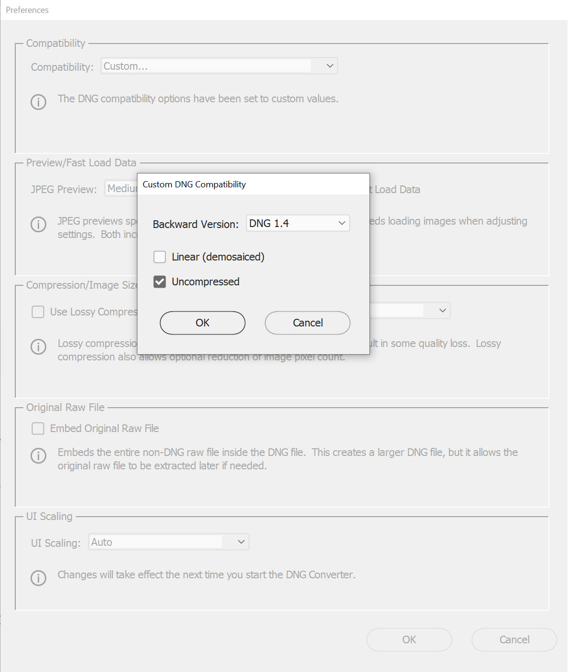

Figure : Make sure to use these settings in Adobe’s DNG converter!

### Organising your data

ELF is pretty good at auto-detecting how your data is organised, but you need to follow a few simple rules. All of your images for one environment should be in the same folder. Different exposures for one scene should be consecutive files, but don't have to have consecutive numbers (e.g. they can be file001.dng and file005.dng, as long as there are no files 002-004). They should also be in order of ascending EV. All of these are usually automatically fulfilled if you shoot with a Nikon camera. The name of your environment folder will be used by ELF as the name of the corresponding dataset, and all its results files. Please make sure to limit the special characters you use in naming your environment folders, as some can cause problems. All environment folders should be in a single **data folder** (also called **root folder**), which should contain nothing else than environment folders.

Let's say this is your folder structure (Windows example):

C  
|--work  
 |----elf_data  
     |---- env1  
                  |---- photo1.dng  
                  |---- photo2.dng  
                  |----...

          |---- env2  
                  |---- photo101.dng  
                  |---- photo102.dng  
                  |----...

In this case, elf_datais your data folder (the one that includes all of your environment folders) and you have two environments, env1 and env2.

## First steps in ELF

To start ELF, open Matlab, navigate to the folder where you downloaded ELF, and simply type “elf”. On your first run, you will be asked to identify your **main data folder** (Figure 2), which is the folder containing all individual project folders (which, in turn, contain your images, see 3.3).

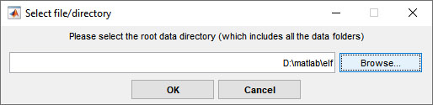

Figure : On your first start, ELF will ask you to identify your data folder.

After selecting this, the program will ask you to select two default output folders:

* a **main/detailed output folder** (which will include the output ELF plots as pdfs, spreadsheet files with the results, and the mean images as high-resolution tifs; Figure 3)
* a **public output folder** (which will just include low-resolution jpgs of the results, and can therefore more easily be shared, e.g. via dropbox; Figure 4).

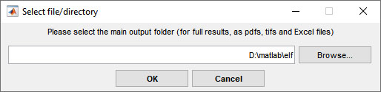

Figure : Next, select your main (=detailed) output folder

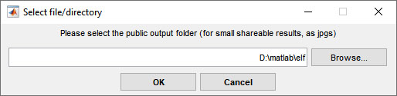

Figure : Finally, select your public output folder

You can later easily change your data folder at the top of the main ELF user interface (Figure 5). If you need to change your output folders, simply start ELF with the reset flag by typing "elf --reset" from the Matlab command window, and you will be asked again to enter your data folder, your main output folder and your public output folder (in that order).

### The ELF user interface

Once the user interface opens, find your data set and check that the indicator number 1 is green, indicating that DNG files have been found in the folder. To unwarp all images and calculate image statistics, press button 2. This step takes the longest time, up to 2 minutes per image depending on processor power. After this step completes, press 3 to calculate the mean image, then 4 to average image statistics and create the final ELF plot for this environment.

Alternatively, rather than pressing buttons 2, 3, and 4, press "Full" to calculate everything for one data set in one go (e.g. overnight). This is not faster than calculating steps individually, but it saves you two button presses.

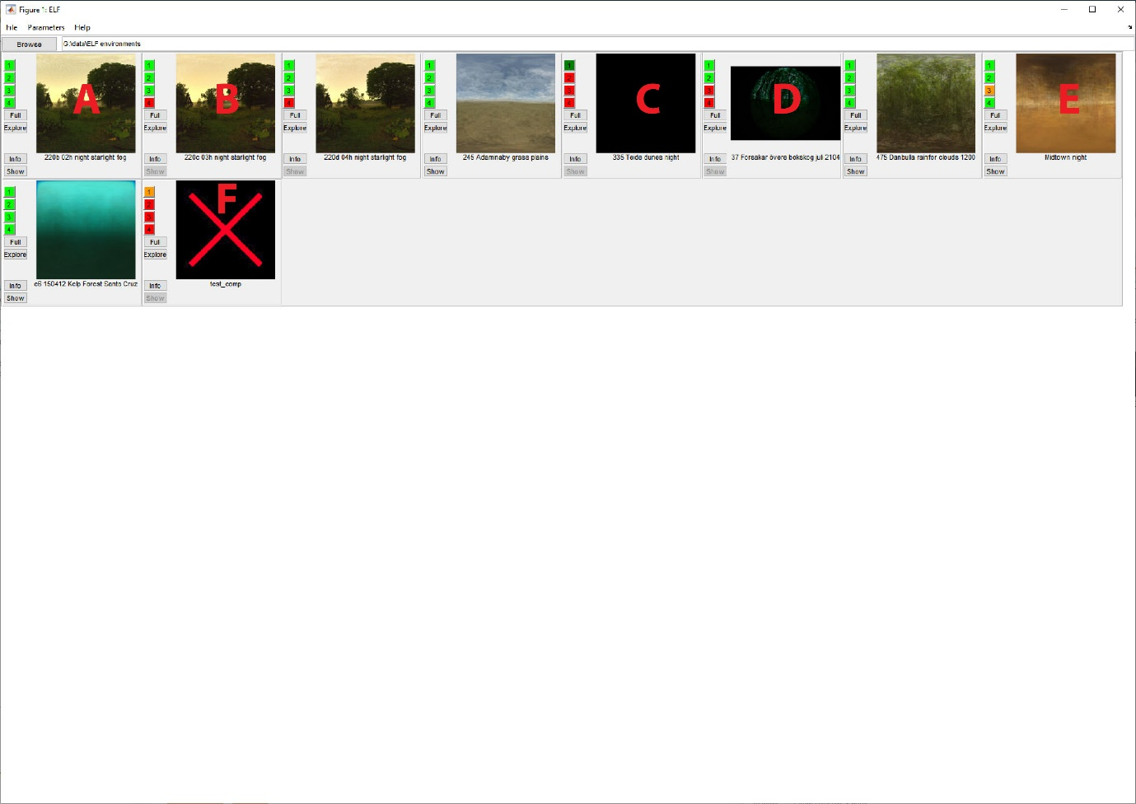

Figure : The main ELF user interface. See Table 1 for details on the button functions. Red letters are added here to mark examples (see Table 2).

Table : Functions of buttons in the main user interface

|  |  |  |  |  |
| --- | --- | --- | --- | --- |
| Button | Function | Colour |  |  |
| 1 | Button colour shows if raw images have been correctly converted to DNG. | Light green | – | DNGs found |
| Dark green | – | NEFs found that need to be converted |
| Orange | – | DNGs found that were converted incorrectly |
| Red | – | No Images found |
| 2 | Calibrates and unwarps all images in an environment, sorts them into scenes, and calculates HDR representations of these scenes.  Intensity statistics are calculated for each exposure and then combined for scenes based on individual pixel reliability. | Light green  Red  Orange | –  –  – | Step calculated  Step not calculated  Step calculated, but a previous step was since updated |
| 3 | Calculates the mean image for an environment as the mean of all normalised HDR scenes. |
| 4 | Averages the intensity statistics for an environment, plots the results, and saves results plots and spreadsheets. |
| Full | Calculates 2-4 |  |  |  |
| Explore | Displays thumbnails for each scene (Figure 6). Use to check for proper HDR calculation or identify problematic scenes. |  |  |  |
| Info | Shows an overview of camera settings, dates, and times (Figure 7). |  |  |  |
| Show | Displays the intensity mean and mean image for a dataset. It recalculates the intensity summary, but not the mean image. |  |  |  |

Table : Examples from Figure 5

|  |  |
| --- | --- |
| Example | Explanation |
| A | A fully processed environment (all buttons green) |
| B | A partially processed environment (step 4 still needs to be calculated) |
| C | A fully unprocessed environment; raw images still need to be converted to DNG; no preview image can be displayed |
| D | A partially processed environment (step 3+4 still need to be calculated); since the mean image is not available yet, the first scene is displayed (often quite dark) |
| E | A fully processed environment; the orange button 3 indicates that step 2 (scene-processing) was redone after step 3 was calculated, so step 3+4 might need to be redone |
| F | An environment where a problem has occurred. Hover over button 1 or check the command window for error details. Most likely, the DNG conversion was done wrong. |

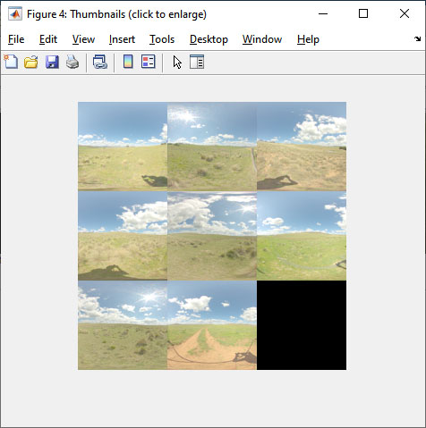

Figure : The “Explore” button displays a collage of all scenes in an environment. Click on any of the thumbnails to see an enlarged version. This view can be helpful to discover problematic scenes (i.e. with excessive saturation, or moving objects)

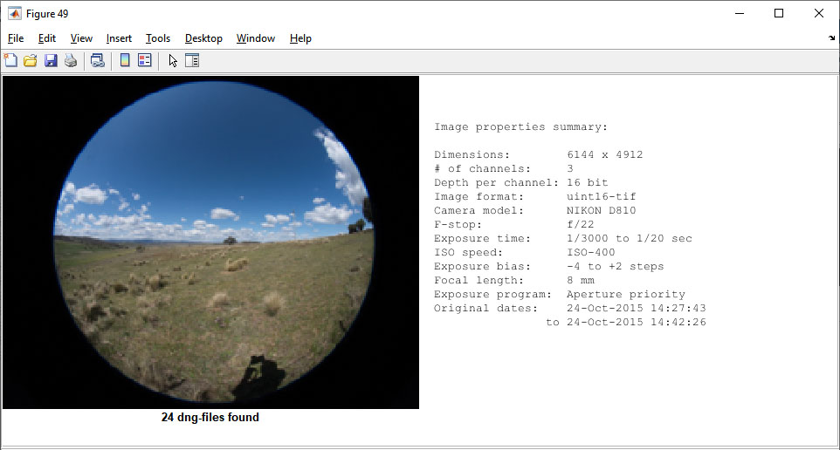

Figure : The “Info” button shows an overview of camera settings in an environment

### Output format

Apart from the standard ELF plots (please see our published papers for explanation), ELF also stores all plotted data in a CSV spreadsheet (this can be read into Excel or many other programs by using the “Import” function), formatted as shown in Figure 8:

The first five lines contain overall image statistics (mean-based and median-based) for each channel and “white”, whereas the rest of the spreadsheet contains the elevation-dependent vertical gradients for each channel.

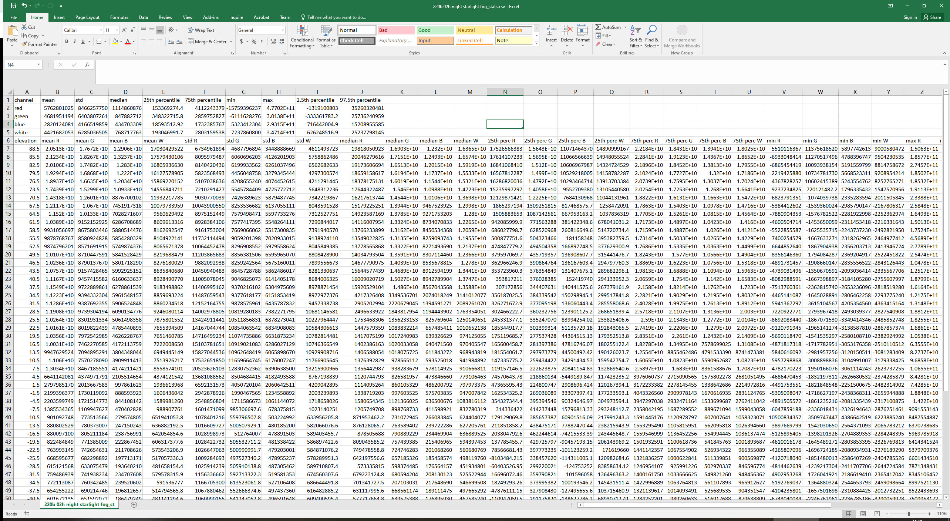

Figure : The data format in the CSV output file for each environment

### Warnings

If ELF encounters problems with an environment that do not make processing impossible, but might indicate large noise or uncertainty, it will display a red warning label on the final ELF plot. Usually, these problems are related to long exposure times or high ISO settings without corresponding dark images (6.3), or with dark images that were not taken at the same time as the rest of the dataset. The easiest way to get more information about the warnings if to redo step 2 and check the Matlab command window for warnings encountered during the dark correction phase (it’s one of the first things ELF does in that step).

## Advanced ELF

### Bulk-calculating datasets

Instead of using the ELF graphical user interface, you can calculate all ELF results programmatically by writing Matlab scripts. These are the functions you need to call for each step (see the function definitions for input and output arguments).

* Step 1: Performed outside ELF, using Adobe DNG converter
* Step 2: elf_main1_HdrAndInt.m
* Step 3: elf_main2_meanimage.m
* Step 4: elf_main3_intsummary.m

Alternatively, you can use calc_wholefolder.m, which will first ask you for your **data folder** (i.e. the folder that contains all of your environment folders, which in turn contain the images). After you select the data folder and output folders, the program will calculate the mean images and intensity-related statistics for **all** environments in the data folder. Computation time depends largely on your processor; on a fast desktop machine, it should be no more than 1 min per scene.

### Customising ELF plots with the .env file

To customise the ELF plots for your project, you can create and modify a .env file in the config folder. It is a text file that can be opened with any text editor. To get your first copy of this .env file, either make a copy of config/defaults/_defaults.env and rename it to .env, or simply run ELF once and it will create a default file the first time it is needed (when plotting a summary plot).

Using the .env file, you can change things like plot spacing, font sizes, line styles, widths and colours, plot axis ticks and labels, and activate/deactivate plot elements (such as the elevation zones, reference radiances, titles, info fields, etc.). You can also use it, in theory, to recreate the original ELF plot style (by following the example _defaults_v0.1.env file).

**Please maintain the layout of your .env file carefully, or ELF might not be able to read it properly!**

##### Environment file syntax

ELF uses the following rules to understand the content of the environment file:

* Each line must be in VAR=VAL format.
* Lines beginning with # are processed as comments and ignored. If # appears mid-line, the rest of that line is treated as a comment and ignored.
* Blank lines are ignored.
* There is no special handling of quotation marks. This means that they are part of the VAL.

### Bracketing files

If you used the camera’s bracketing function during image acquisition, ELF will automatically detect which images belong together (it does so by detecting the pattern of values of the ExposureValue tag from EXIF information). If you have used manual mode to create your own brackets (which is necessary, e.g., with long exposures at night), this method will not work. By default, ELF then treats every single exposure as an individual scene. To prevent this, simple place a text file named “brackets.info” into the environment folder, which must include two columns: the starts and ends of brackets, in relative image numbers, separated by tabs.

For example, if you have three scenes, each containing three images, your brackets.info file should look like this:

1 3  
4 6  
7 9

Again, notice that the numbers in each row must be separated by tabs, not spaces!

### Dark images

Our calibration measurements have shown that for short exposures and low ISO values, noise in the Nikon cameras is low and predictable. However, once you exceed certain threshold values (for the D850: exposures >1s or ISO >1600), noise needs to be corrected for. This is ideally done by taking dark images, i.e. images that are taken in exactly the same circumstances as the real images (i.e. same camera settings, same temperature, …), but with the light path into the camera blocked, e.g. by putting on the lens cap and/or tightly covering the camera with a black cloth. When you record an ELF measurement where dark images are necessary, simply record one or more dark images at EACH COMBINATION OF exposure/ISO settings that you use in your measurement (Aperture does not affect the internal noise, so its value will be ignored). For a longer measurement, consider taking at least two sets of dark images at each setting, one before and one after your recording session. If ELF finds two (or more) such images for a given setting, it will linearly interpolate the noise between those two (or more) times.

To use the dark images, simple place them (after DNG conversion, of course) in a folder named “dark” inside your environment folder. ELF will automatically correct all images in that environment that use those same exposure/ISO settings.

## FAQ / Troubleshooting

Here are a number of commonly encountered problems, and their solutions.

##### Problem: I’m getting lots of “MException” error messages!

Details: Error messages in the Matlab command window, looking like this

"MException with properties:

identifier: 'MATLAB:heterogeneousStrucAssignment'  
message: 'Subscripted assignment between dissimilar structures.'  
cause: {}  
stack: [2x1 struct]"

Solution: This happens when your image files have not been fully copied or are corrupt. Re-convert your NEF files to DNG.

##### Problem: ELF shows lots of warnings about improper elements in the TIFF

Solution: When converting your images with DNG Converter, the “Uncompressed” checkbox was not checked. Read up on converting (3.2), and convert them again.

##### Problem: ELF tells me I have selected the wrong root folder

Details: I get a “Warning: Root folder is empty. Please enter the correct root folder in elf_para.m”

Solution: Most likely, you have selected one of your environment folders as the root folder. Read up on the root folder (3.3), and run "elf --reset" from the Matlab command window, to be asked again to enter your data folder (as well as your main output folder and your public output folder).